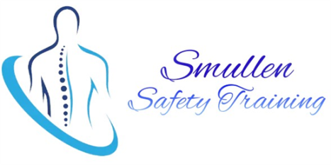  Did you Know?  In 2023 – there was 43 fatal work related accidents and 9,070 non – fatal injuries: 33% of these workplace injuries were a lack of manual handling training  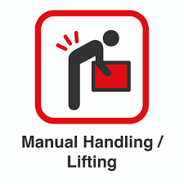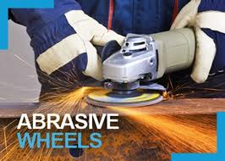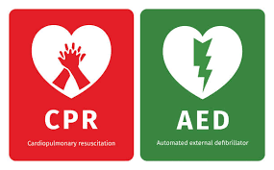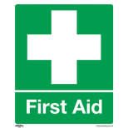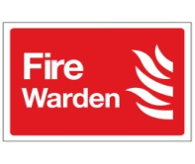  - QQI Level 6 Qualified  - RTITB Qualified  - Tailored packages available to suit all businesses  - Professional and efficient  Don’t be negligent, be intelligent and train your staff with Smullen Safety Training  QQI Level 6 and RTITB Qualified Instructors.  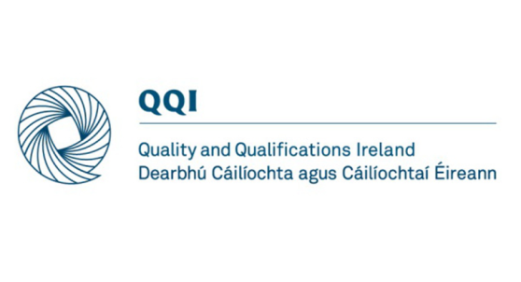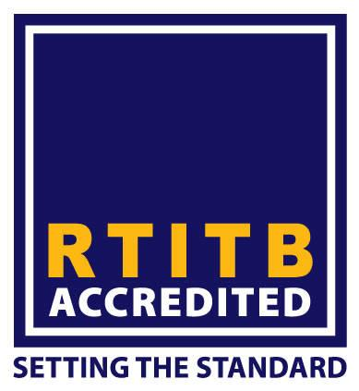 | Manual Handling Forklift Training Pedestrian Powered Truck  Abrasive Wheel Training Reach Forklift truck Pallet Stacker  First Aid Responder Scissors Lifting Moffet  Basic First Aid Mewp + Boom Lifts Combi Lift  Fire Warden and safe use of portable fire extinguishers Llop Pallet Truck VNAMan Up  Cardiac First Responder Power Pallet Truck VNA Man Down  Working at Heights Counter Balance Forklift Pivot Steer  Harness Training Vehicle Mounted Crane Patient handling  Ladder Safety Telescopic Boom  For further information of if you have any questions please contact Stephen Smullen  Ph. 0871784672 or email:smullensafety@gmail.com

